**E-R diagram for the following text:**

ABC is a famous renowned mobile banking app. This app connects the clients and the Banks via online so that the clients can easily do their day-to-day work hassle-free. The bank has many clients, and a bank contains a unique swift code, Bank name, address (city, country). All the clients are identified by their name (first name, last name etc.), national id number (NID), address, DOB, unique account number. A client can also have multiple phone numbers. A client can use many kinds of payment gateways like online shopping, education fee, transport getaway and a unique payment slip no. Clients may also take bank loans because the bank provides many loans. One client can take one loan at a time. Also, he/she can Withdraw or Deposit money more than one.

Information’s are needed to borrow loans like loan amount, loan no (unique), borrow date. The mobile bank also has a manager. A manager has name, unique id, address, salary. Also, manager can have contact numbers. Employees are managed by the manager. All the employees have their name, salary, unique id, and multiple phone numbers. Manager organize projects and project contains project name, project serial no and project date.

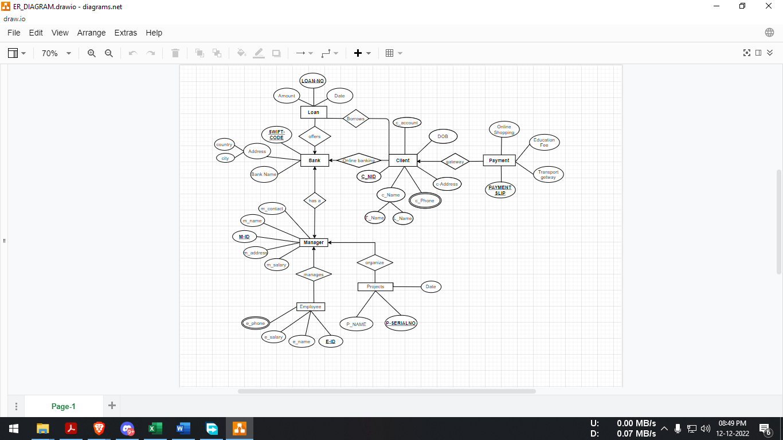

**Normalization**

**OFFERS**

UNF: Amount, **LOAN-NO**, date, **swift-code**, city, country, bank-name.

1NF: **LOAN-NO,** **SWIFT-CODE,** Amount, Date, city, country, Bank-Name.

2NF:

* 1st**: loan-no,** amount, date, swift-code (foreign key because one- many)
* 2nd: **swift-code,** bank-name, city, country

3NF:

* 1st: **loan-no**, swift-code, amount, date
* 2nd: **City**, country
* 4th: **swift-code**, bank-name, city (foreign key).

**ONLINE BANKING:**

UNF: **Swift-code**, bank-name, city, country, **c-nid,** f-name, L-name, ***c-phone,*** dob, c-address, c-account.

1NF: **swift-code, c-nid, c-phone,** bank-name, city, country, f-name, , l-name, dob, c-address, c-account.

2NF:

* 1st: **swift-code,** bank-name, city, country,
* 2nd: **c-nid**,  **c-phone,** f-name, l-name, dob, c-address, c-account, swift-code.

3NF:

* 1St:**swift-code**, bank-name, city;
* 2nd: **City**, country
* 3rd: **c-account,** dob, f-name, l-name, c-address;
* 4th: **c-nid**, **c-phone**, swift-code, c-account;

**BORROW:**

UNF: **loan-no** , date, amount, **c-nid**, f-name, l-name, c-address, dob, c-account,c-phone.

1NF: **loan-no, c-nid, c-phone,** c-account, date, amount, f-name, l-name, c-address, dob.

2NF:

* **C-nid, c-phone,** c-account, f-name, l-name, c-addresss, dob, loan-no .
* **Loan-no,** date, amount, c-nid.
* **C-nid, Loan-no.**

3NF:

* **c-account,** f-name, l-name, c-address, dob.
* **c-nid, c-phone,** c-account, loan-no.
* **Loan-no,** date, amount, c-nid.
* **C-nid, loan-no**

**GETWAY**

UNF: **c-nid,** f-name, l-name, dob, c-account, c-address, c-phone, payment**-slip**, online-shopping, education-fee, transport-getway

1NF: **c-nid, payment-slip, c-phone,** f-name, l-name, dob, c-account, c-address, online-shopping, education-fee, transport-getway

2NF:

* **C-nid, c-phone,** f-name, l-name, dob, c-account, c-address.
* **Payment-slip**, online-shopping, education-fee, transport-fee, c-nid.

3NF:

* **c-account,** f-name, l-name, dob, c-address.
* **C-nid,** c-phone, c-account.
* **Payment-slip**, online-shopping, education-fee, transport-fee, c-nid

**BANK HAS A MANAGER:**

UNF: **SWIFT-CODE**, city, country, bank-name, **m-id**, m-name, m-contact, m-address, m-salary

1NF: **SWIFT-CODE**, city, country, bank-name, **m-id**, m-name, m-contact, m-address, m-salary

2NF:

* **Swift-code,** bank-name, city, country.
* **M-id,** m-name, m-contact, m-address, m-salary, swift-code.

3NF:

* **Swift-code**, bank-name, city,
* **city,** Country.
* **m-contact**, m-name, m-salary, m-address.
* **m-id,** swift-code, m-contact.

**MANAGE**

UNF: **M-ID,** M-name, m-contact, m-address, m-salary, **E-ID**, e-salary, e-name, e-phone

1NF: **M-id, e-id, e-phone**, m-name, m-contact, m-address, m-salary, e-name, e-salary

2NF:

* **M-id**, m-name, m-contact, m-address, m-salary.
* **E-id**, **e-phone**, e-name, salary, m-id

3NF:

* **M-contact**, m-name, m-address, m-salary
* **M-id**, m-contact
* **E-id, e-phone**, e-name, salary, m-id

**ORGANIZE:**

UNF: **M-ID**, M-NAME, m-contact, m-address, m-salary, **p-serialno**, p-name, date

1NF:

* **M-id, p-serialno,** m-name, m-contact, m-address, m-salary, p-name, date

2NF:

* **M-id**, m-name, m-contact, m-address, m-salary
* **P-serialno** , p-name, date, mid

3NF:

* **m-contact,** m-name, m-address, m-salary
* **M-id,** m-contact
* **P-seralno,** p-name, date, mid

**FINALISATION**

1. **loan-no**, swift-code, amount, date **(BANK_LOAN)**
2. **swift-code**, bank-name, city **(BANK)**
3. **CITY**, COUTNRY (LOCATION)
4. **c-account,** dob, f-name, l-name, c-address **(CLIENT)**
5. **c-nid**, **c-phone**, swift-code, c-account **(ONLINE_BANKING)**
6. **c-nid, c-phone,** c-account, loan-no **(CLIENT_LOAN)**
7. **Loan-no,** date, amount, c-nid **(LOAN)**
8. **C-nid, c-phone**, c-account **(CLIENT 2).**
9. **Payment-slip**, online-shopping, education-fee, transport-fee, c-nid **(PAYMENT)**
10. **m-id,** swift-code, m-contact **(BANK_MANAGER)**
11. **M-contact**, m-name, m-address, m-salary **(MANAGER)**
12. **M-id**, m-contact **(joint table 2)**
13. **E-id, e-phone**, e-name, salary, m-id **(EMPLOYEE)**
14. **P-serial no,** p-name, date, m-id **(PROJECTS)**

**Table Creation**

**Bank Table:**

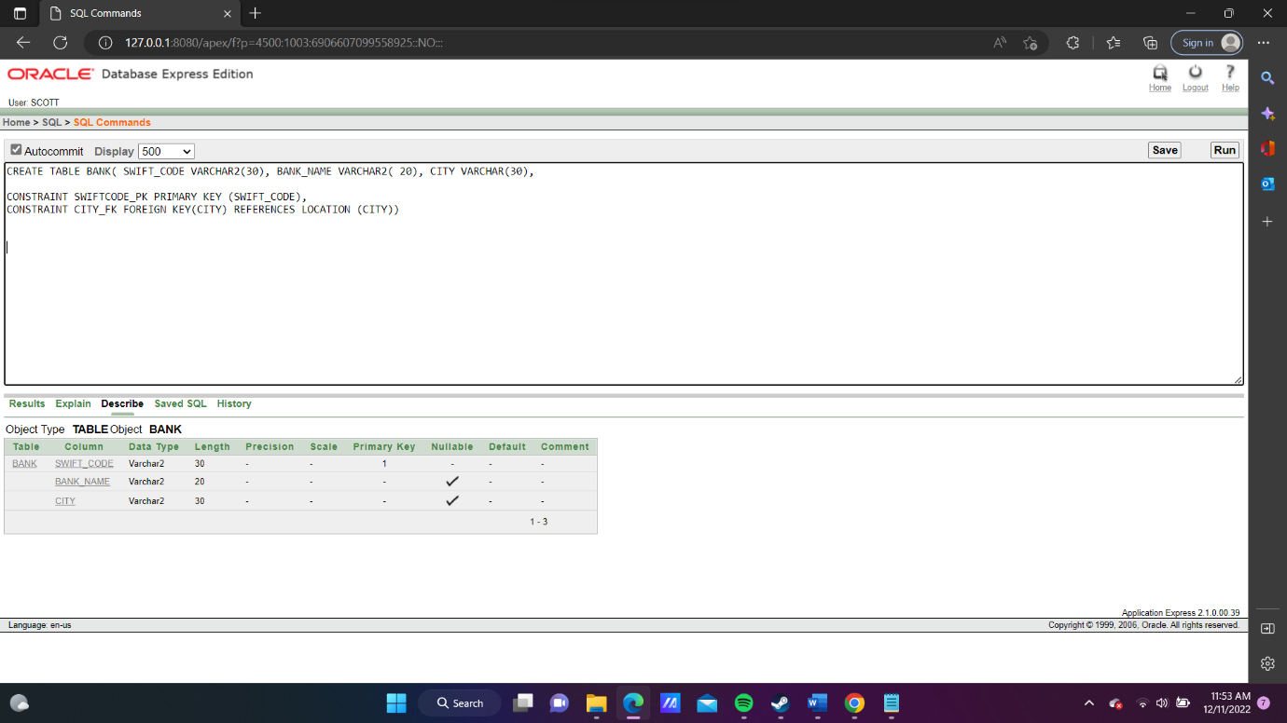

**Bank Loan Table:**

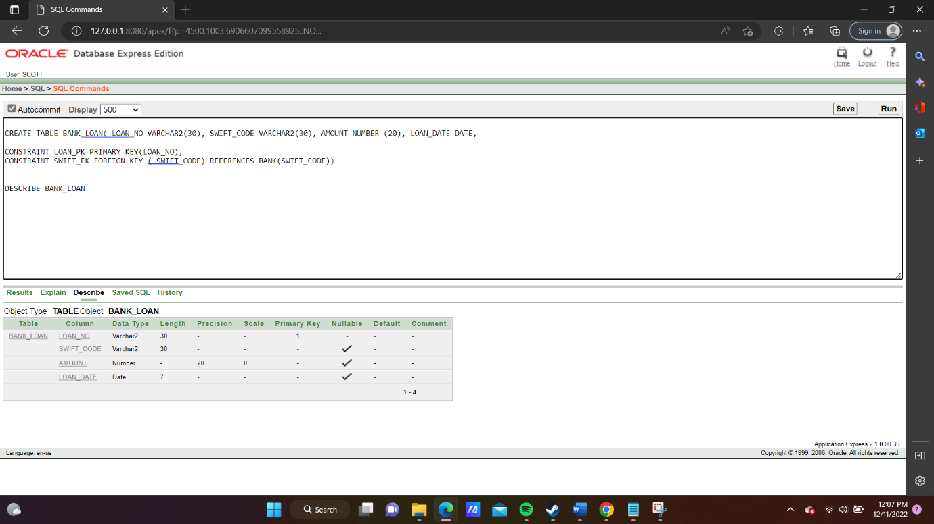

**Bank Manager Table:**

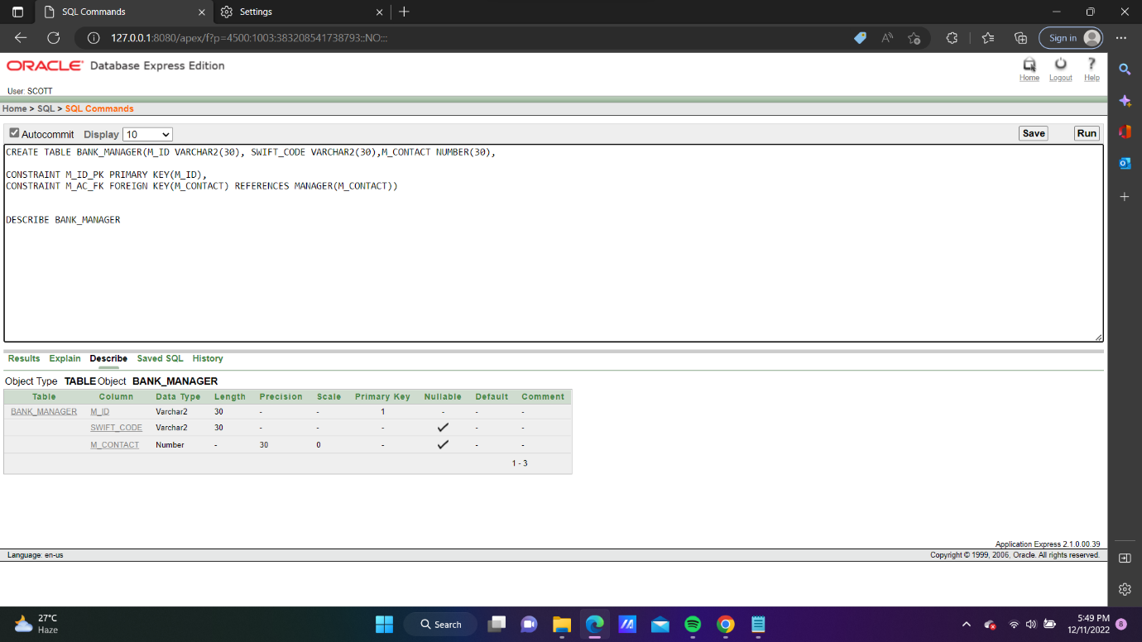

**Client Table:**

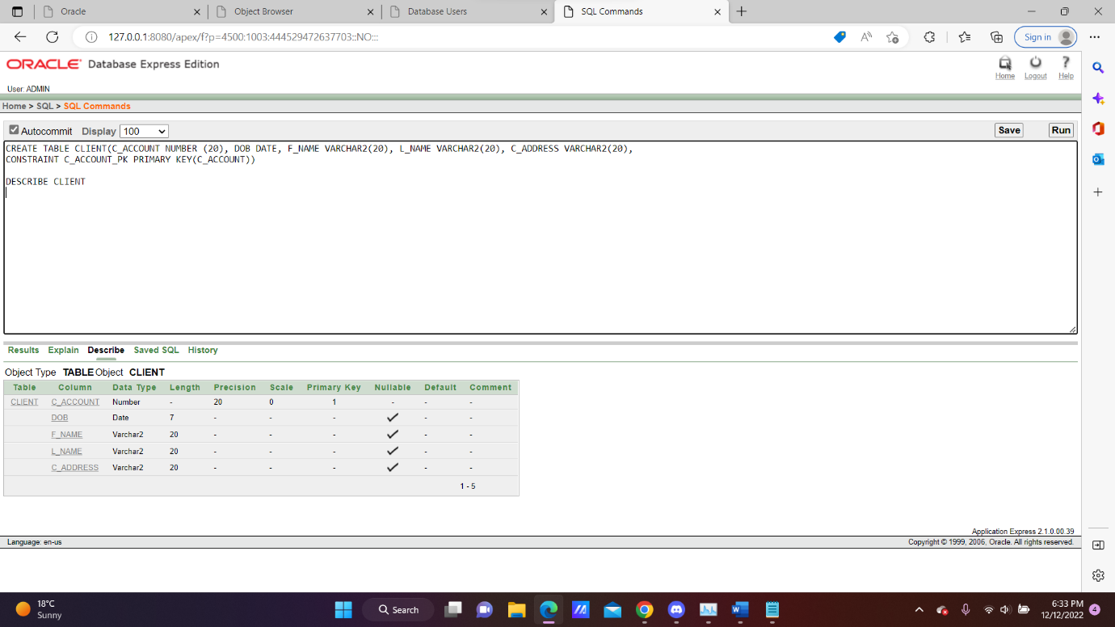

**Client Loan Table:**

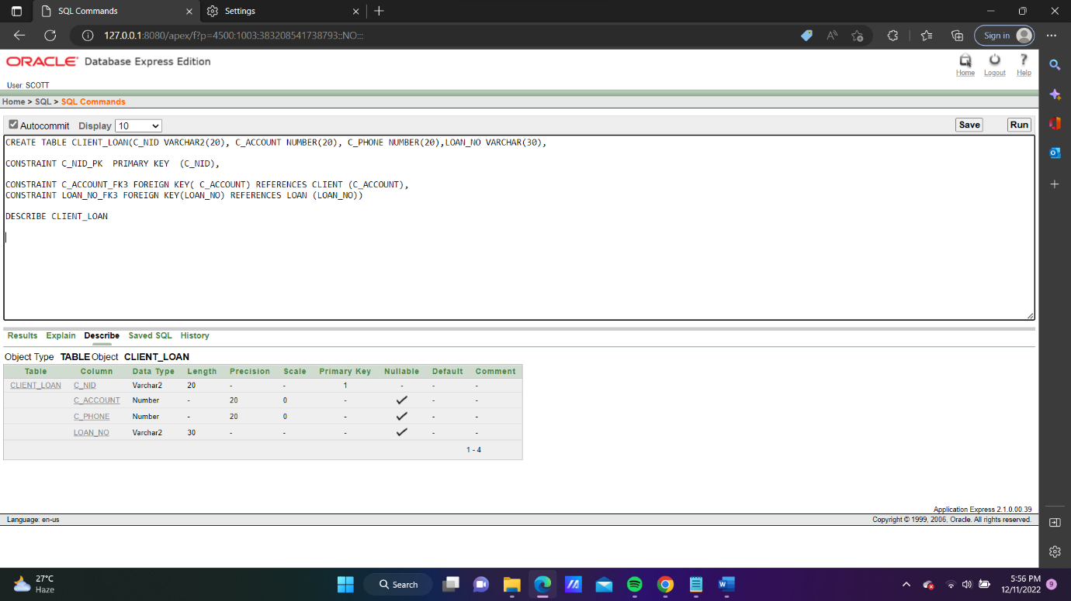

**Client2 Table:**

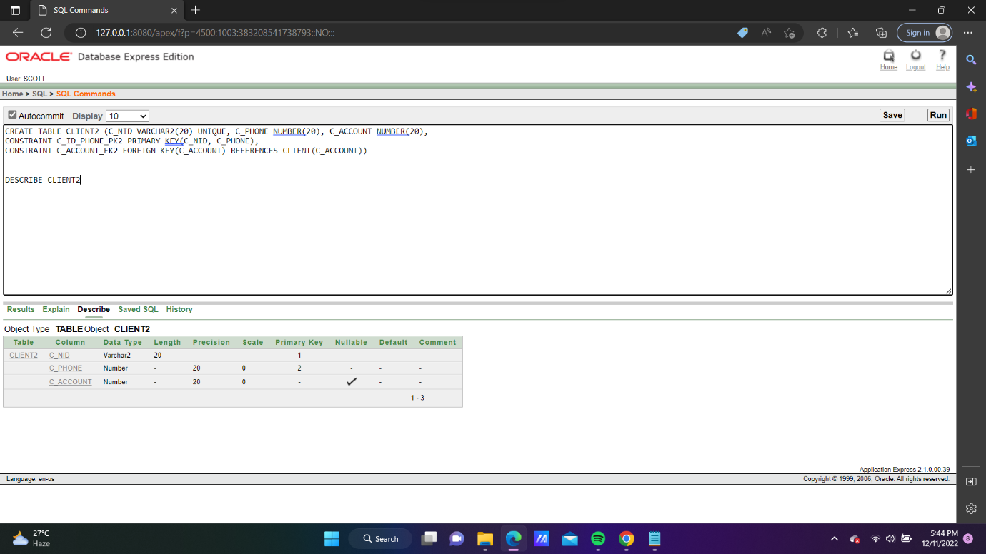

**Employee Table:**

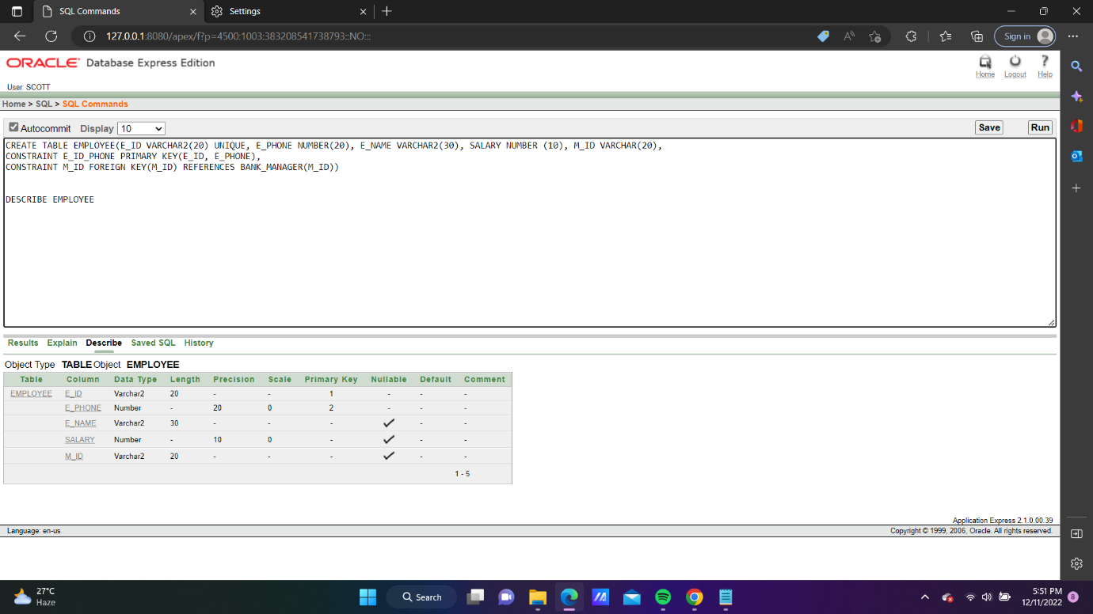

**Joint_Table 2 Table:**

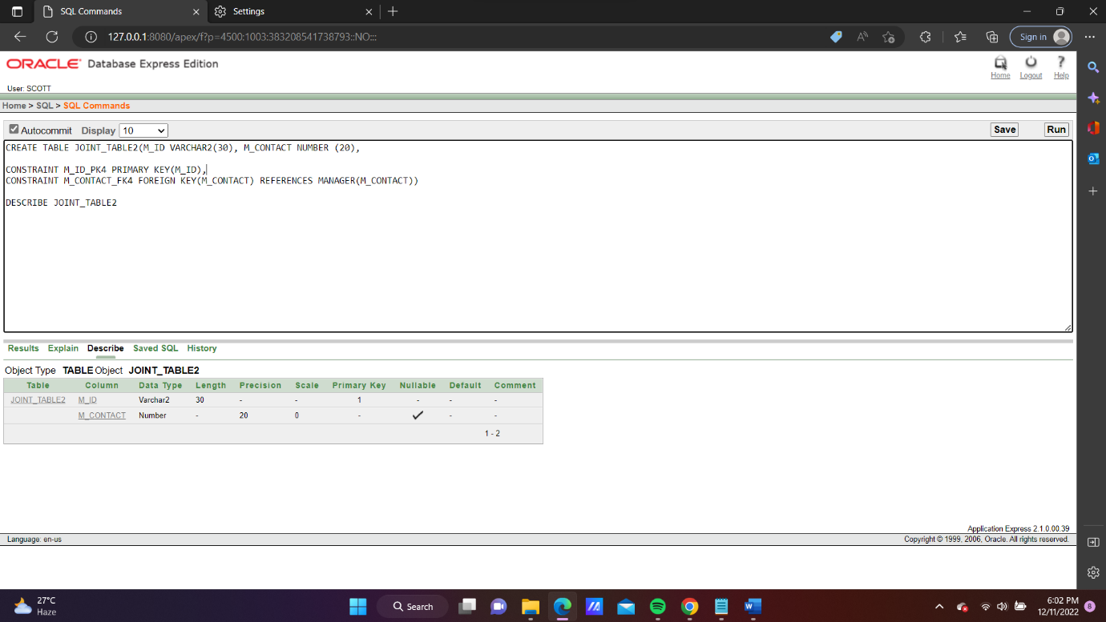

**Loan Table:**

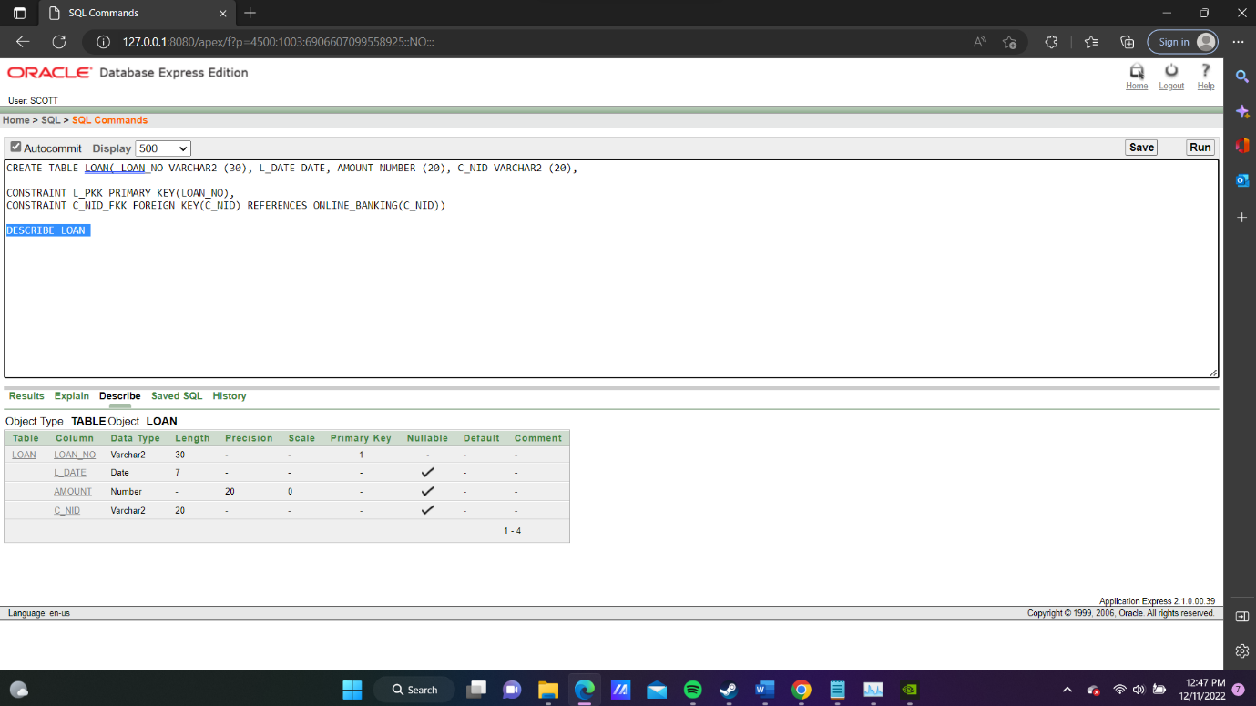

**Location Table:**

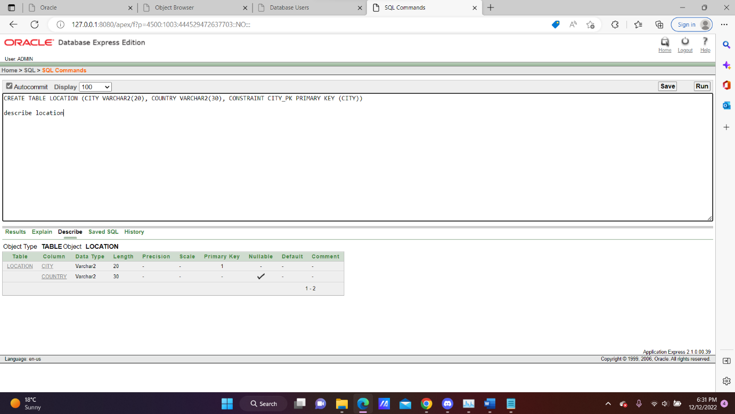

**Manager Table:**

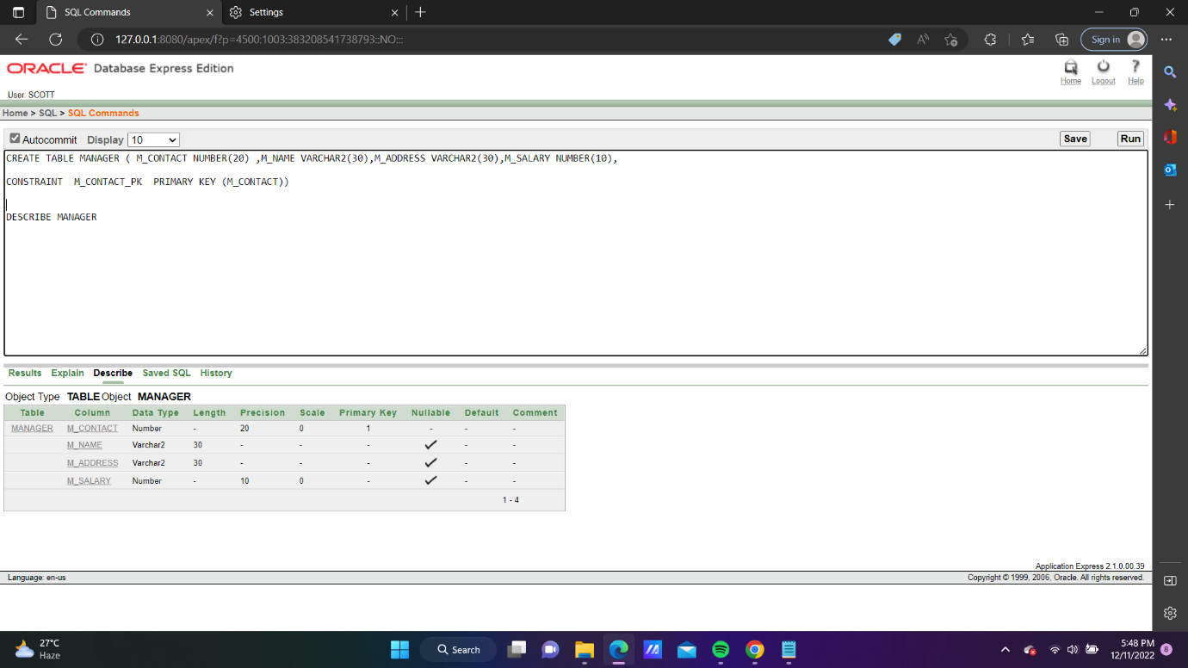

**Online Banking Table:**

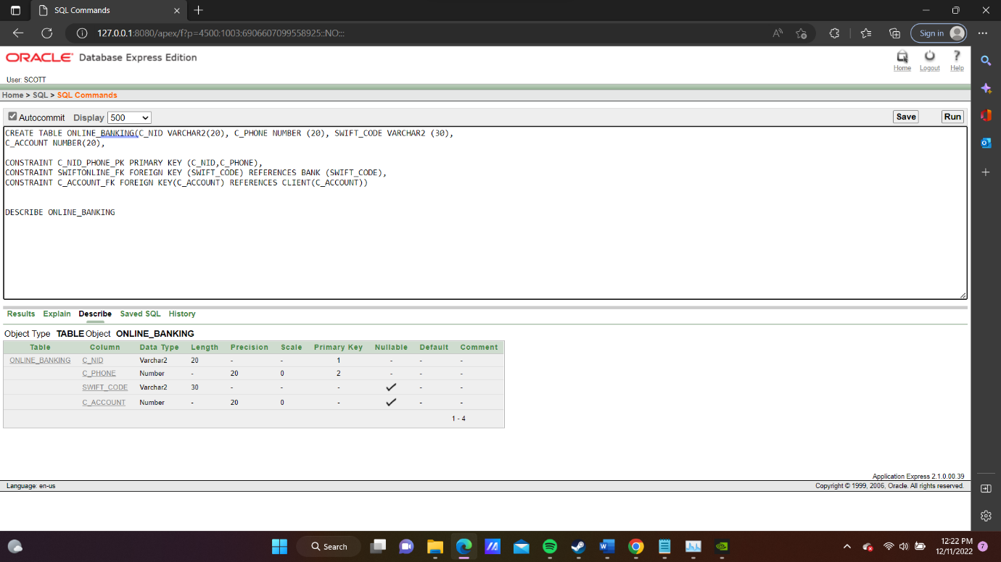

**Payment Table:**

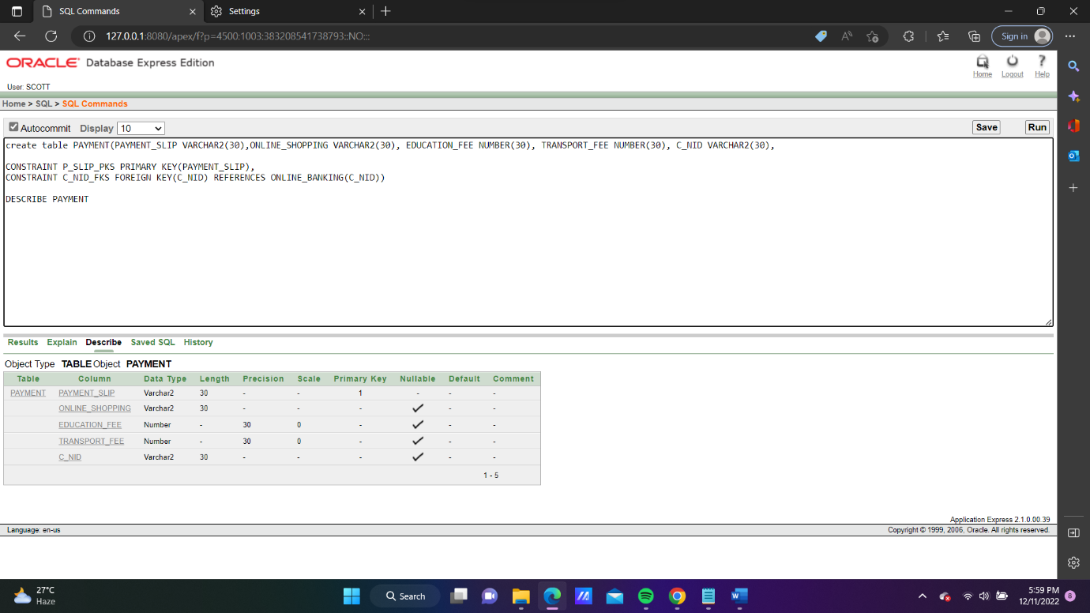

**Projects Table:**

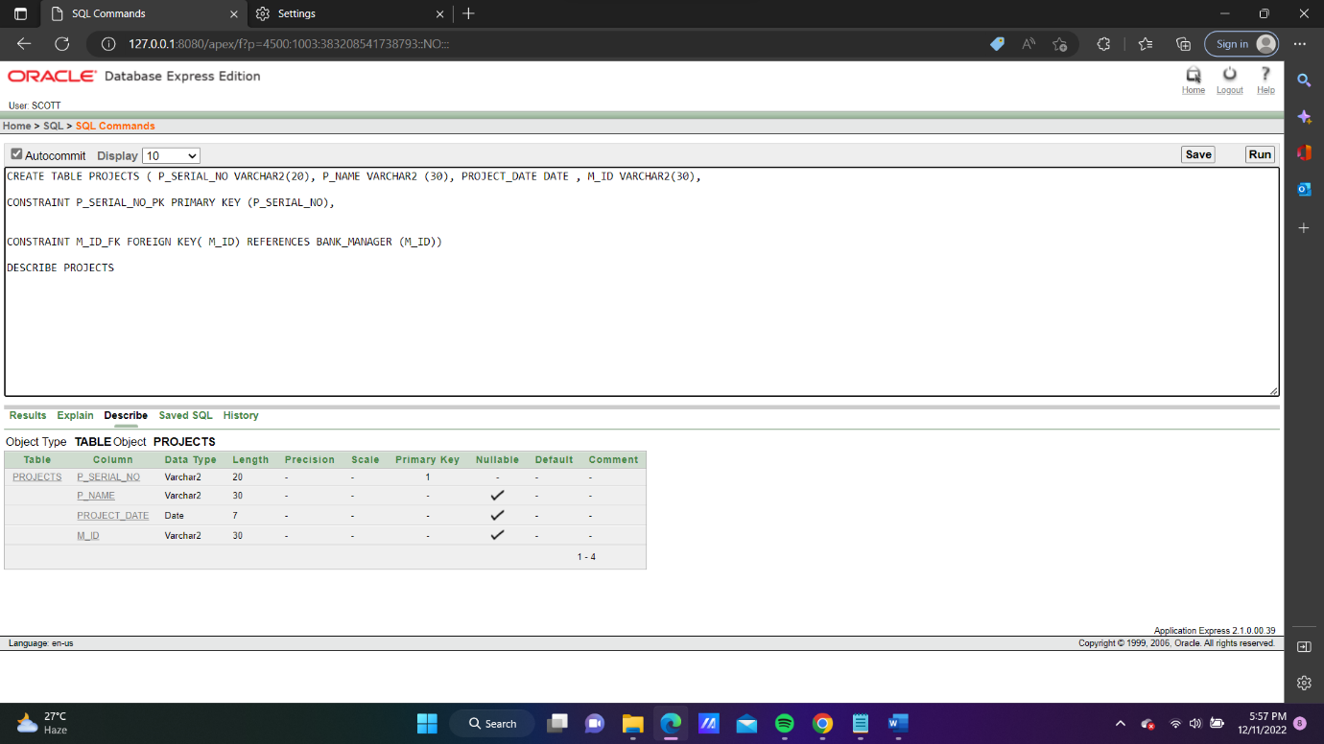

**Data Insertion**

**Data Insertion in Bank Table:**

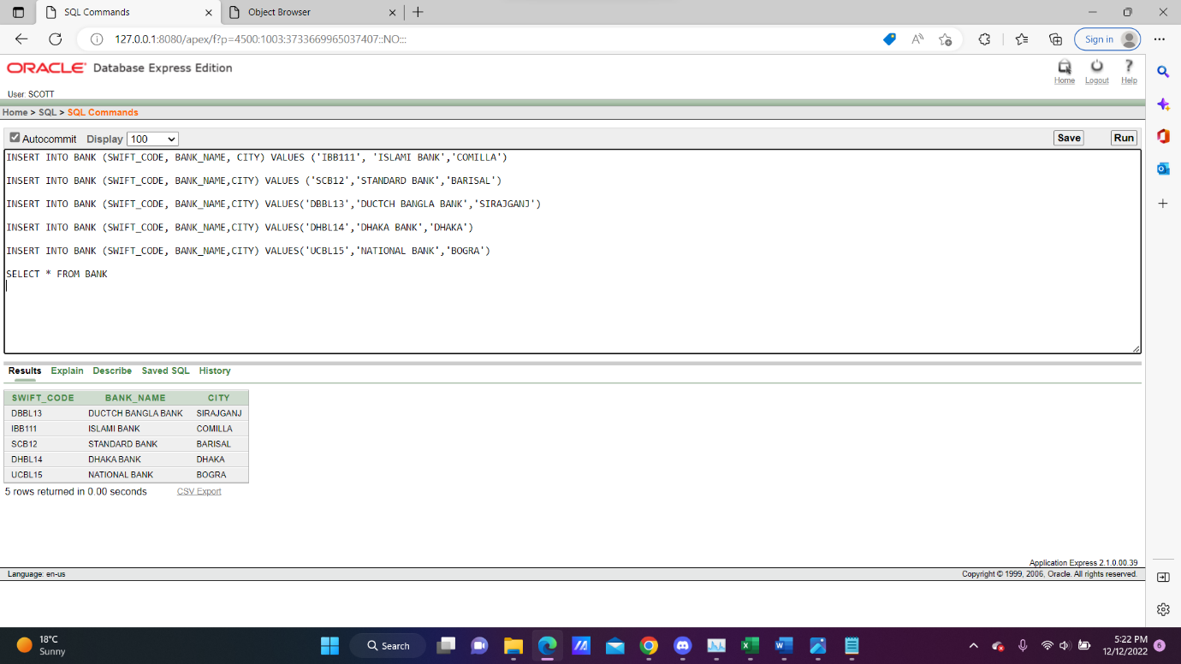

**Data Insertion in Bank Manager Table:**

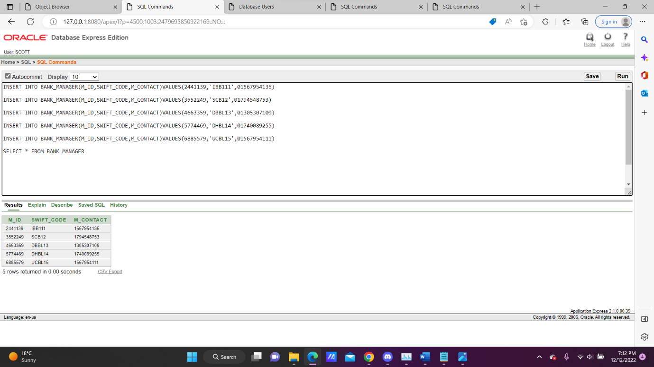

**Data Insertion in Client Table:**

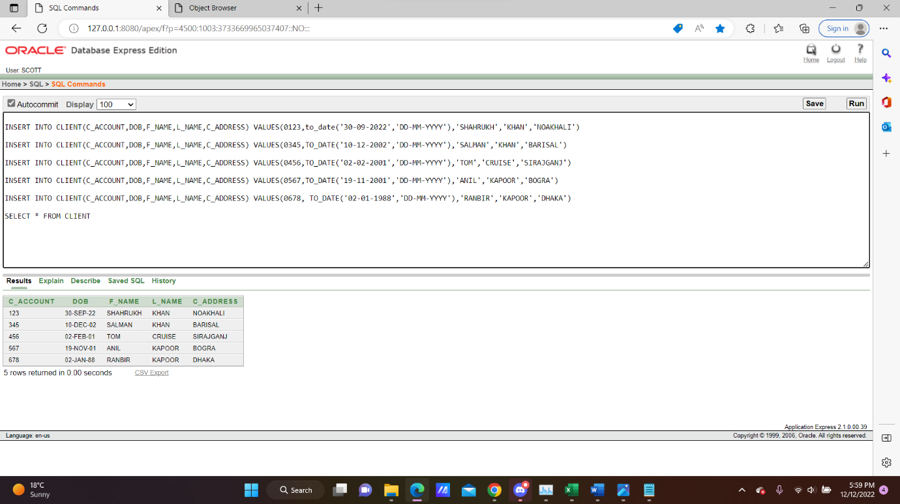

**Data Insertion in Client Loan Table:**

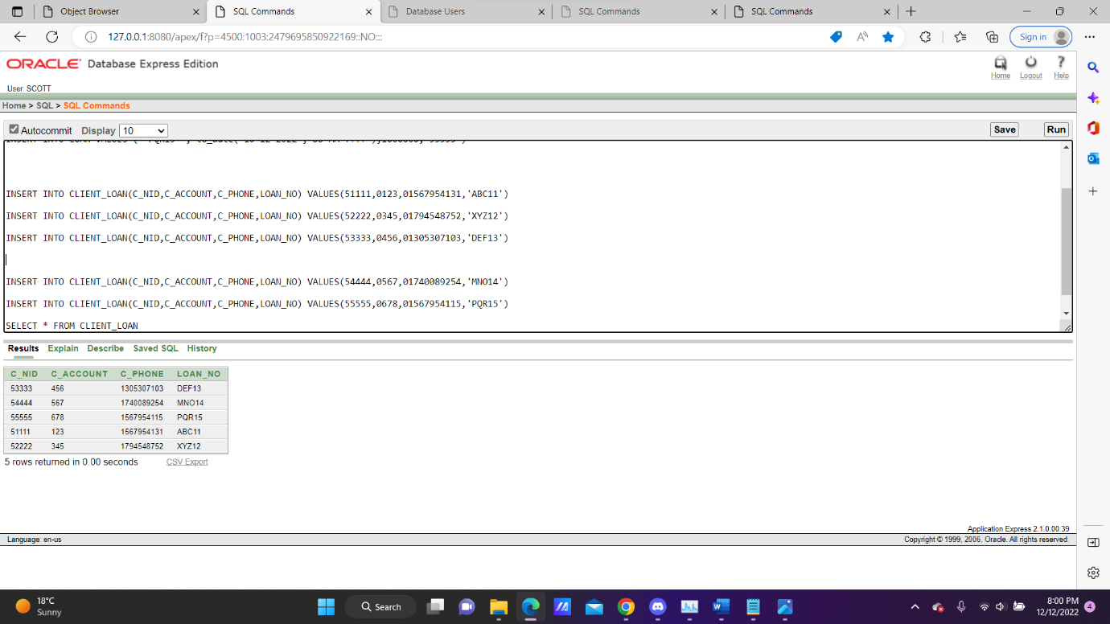

**Data Insertion in Client2 Table:**

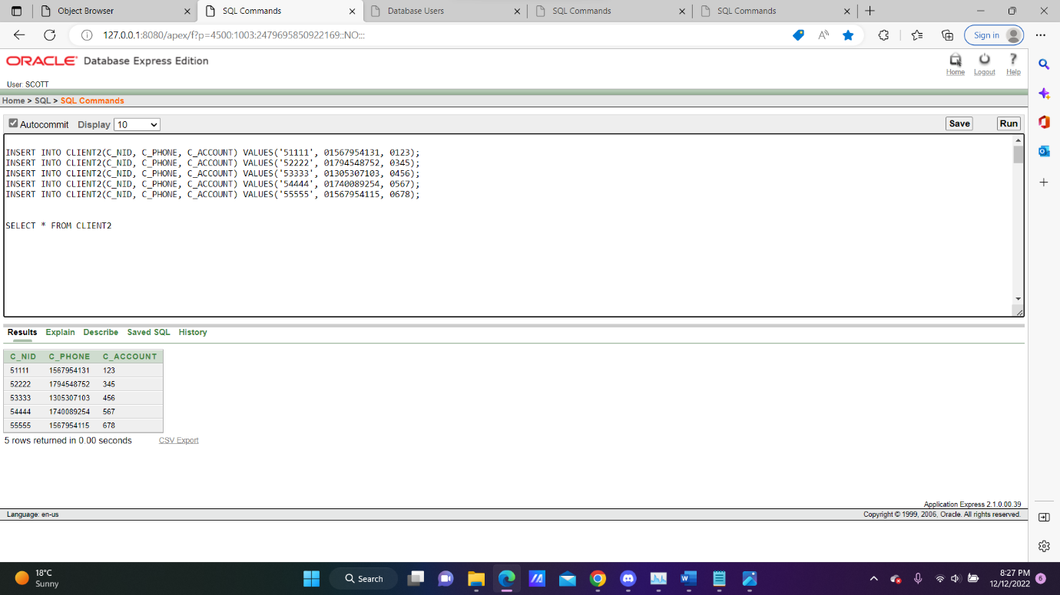

**Data Insertion in Employee Table:**

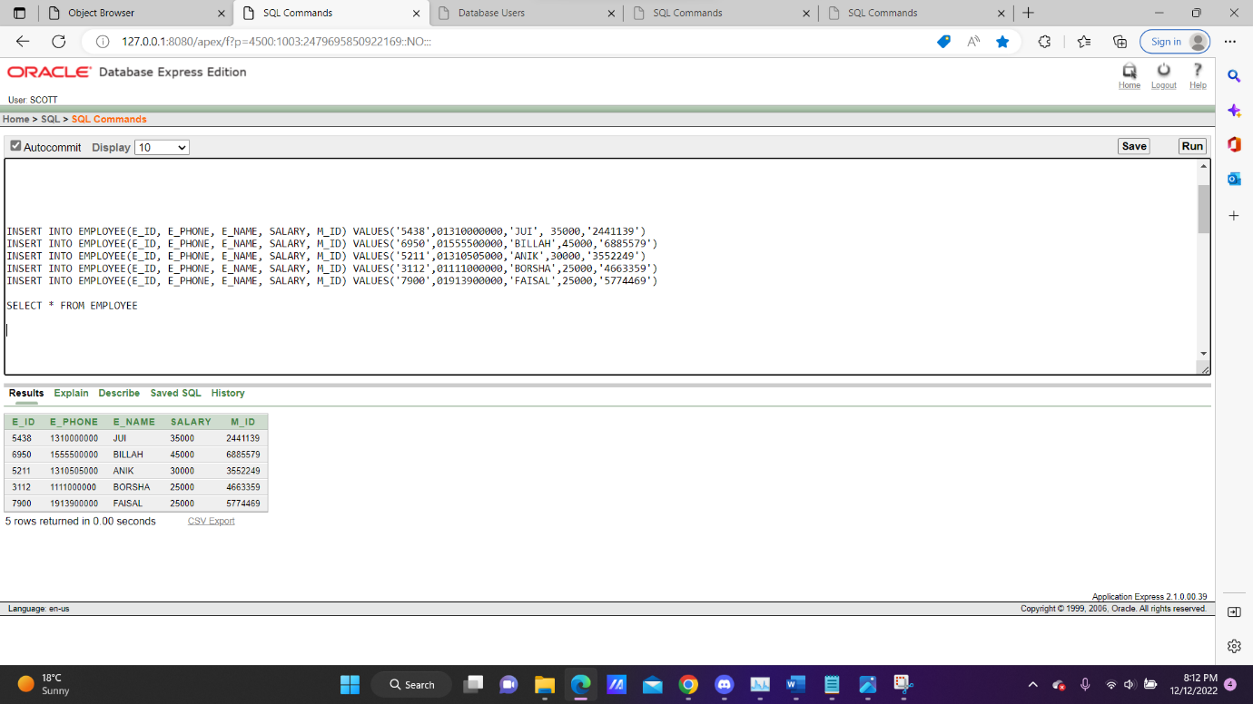

**Data Insertion in Joint_Table2 Table:**

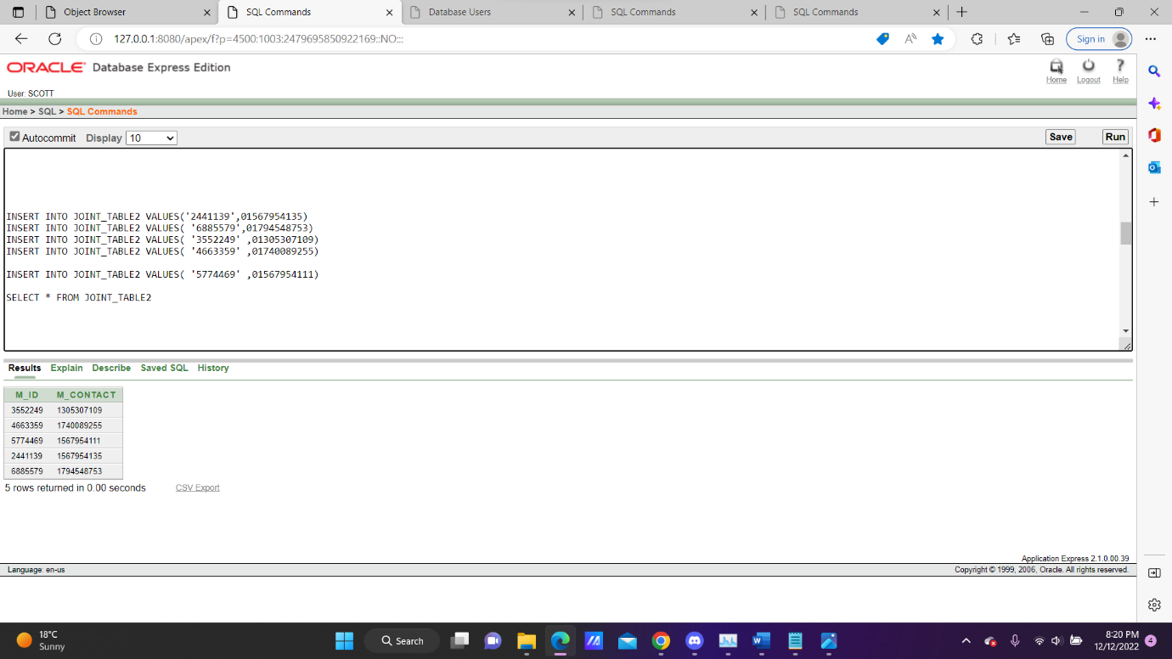

**Data Insertion in Loan Table:**

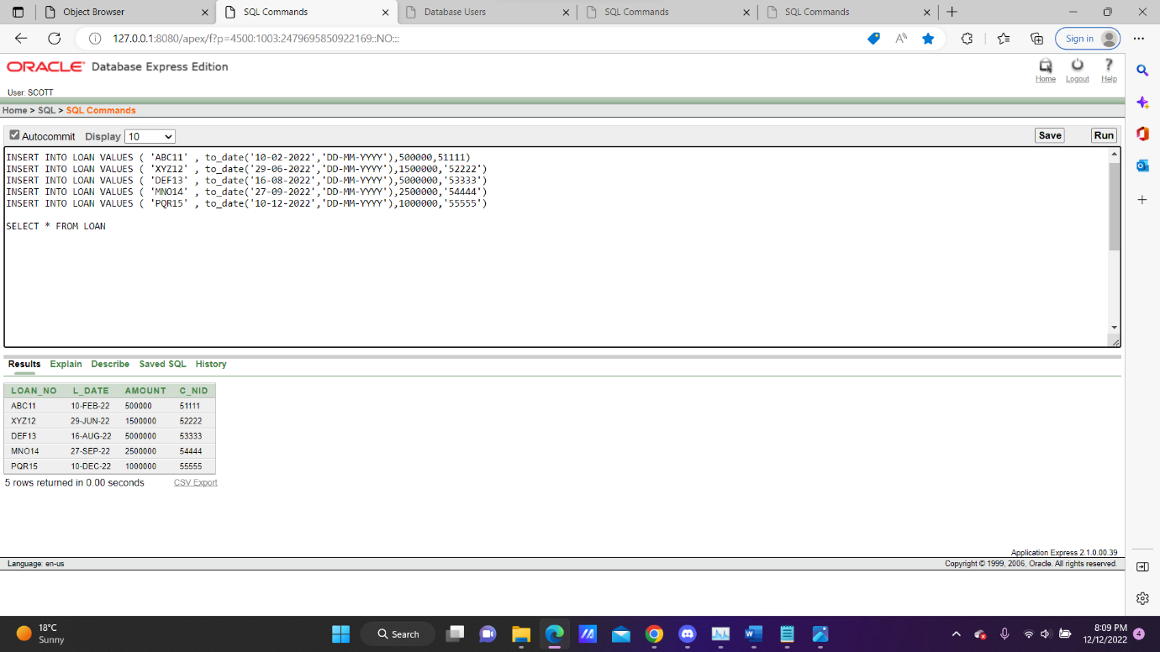

**Data Insertion in Location Table:**

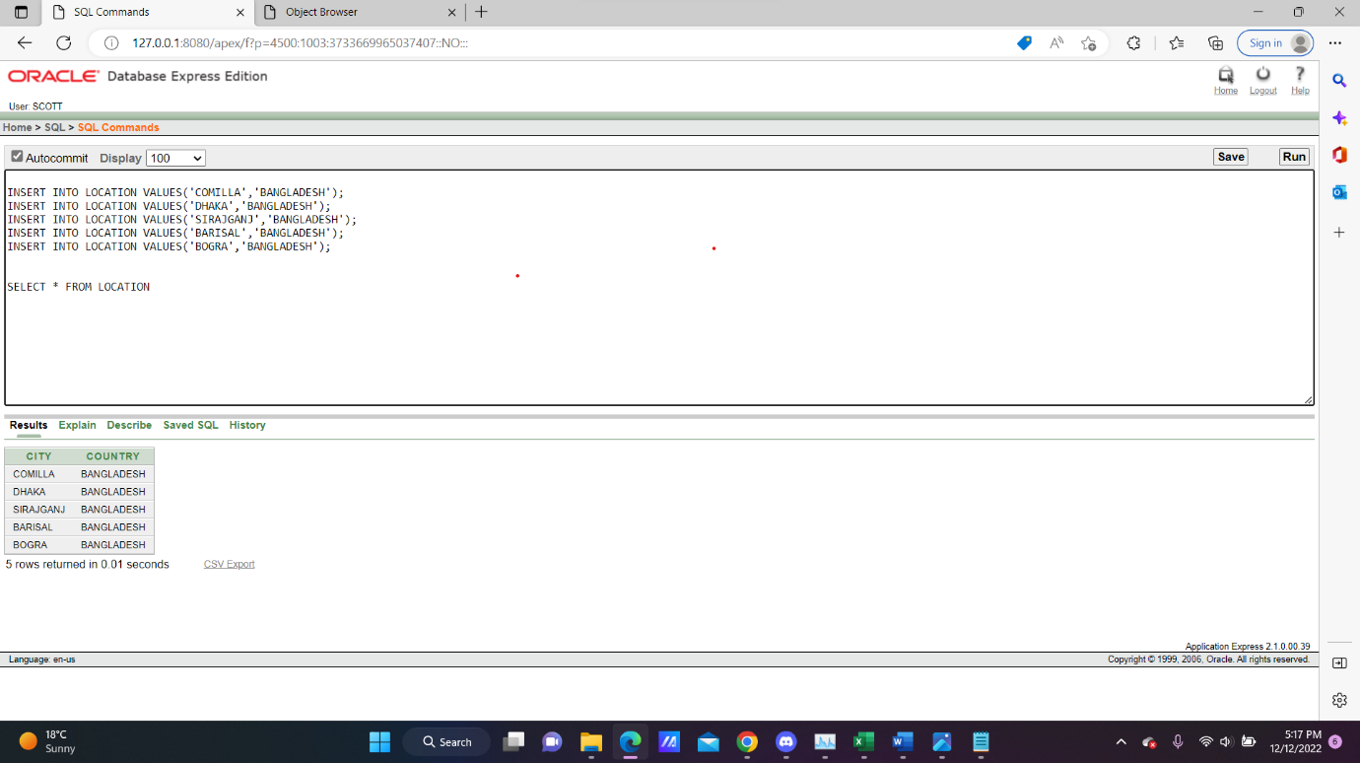

**Data Insertion in Manager Table:**

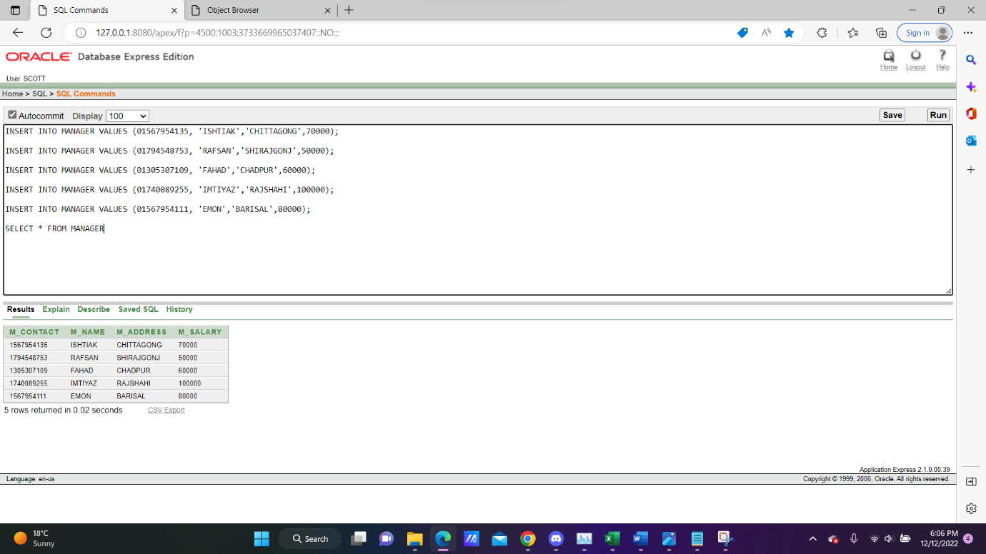

**Data Insertion in Online Banking Table:**

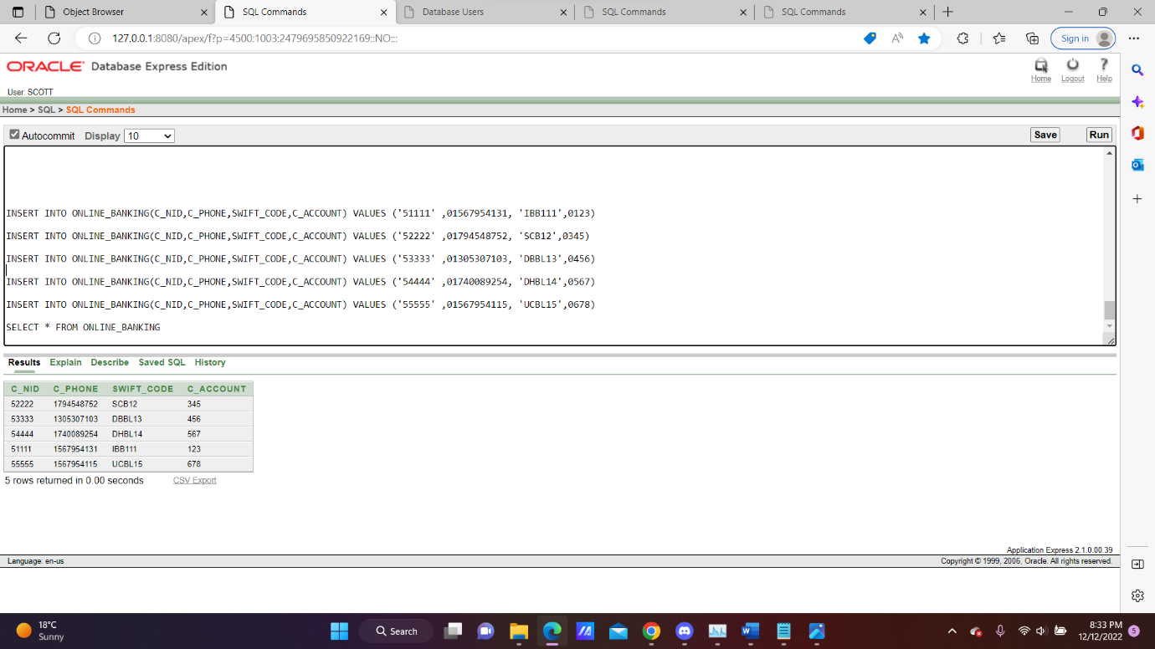

**Data Insertion in Payment Table:**

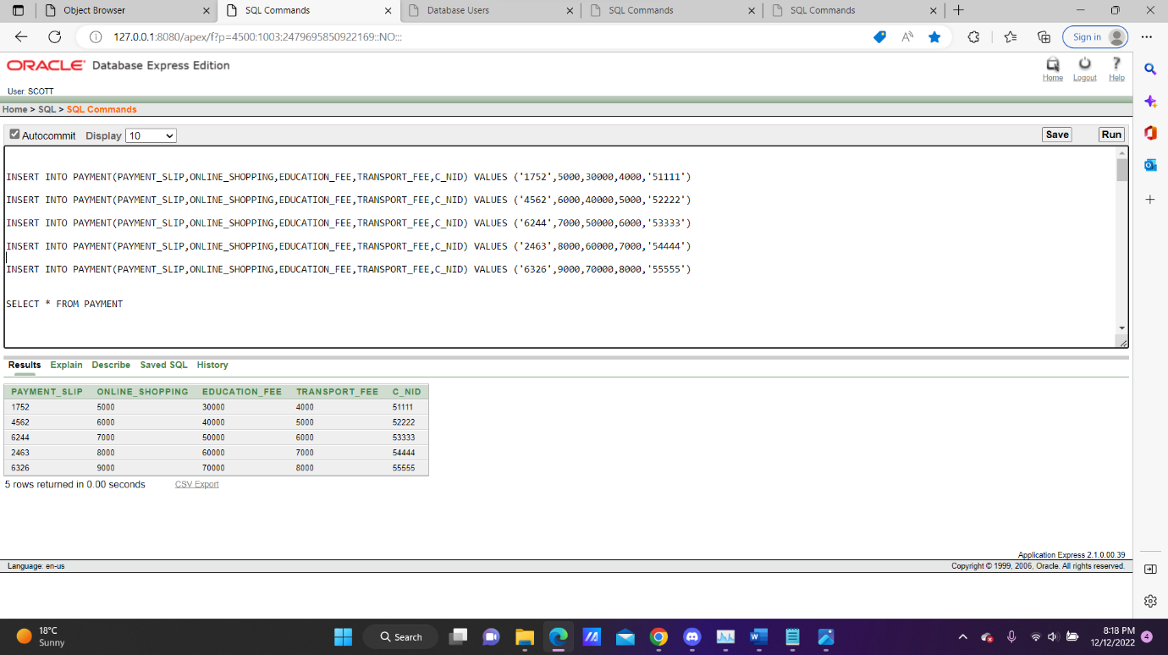

**Data Insertion in Projects Table:**

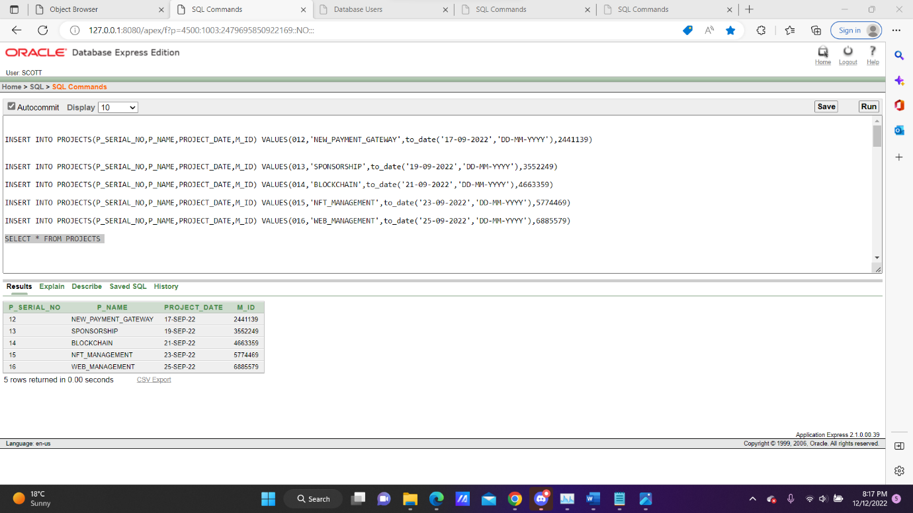

**Data Insertion in Bank Loan Table:**

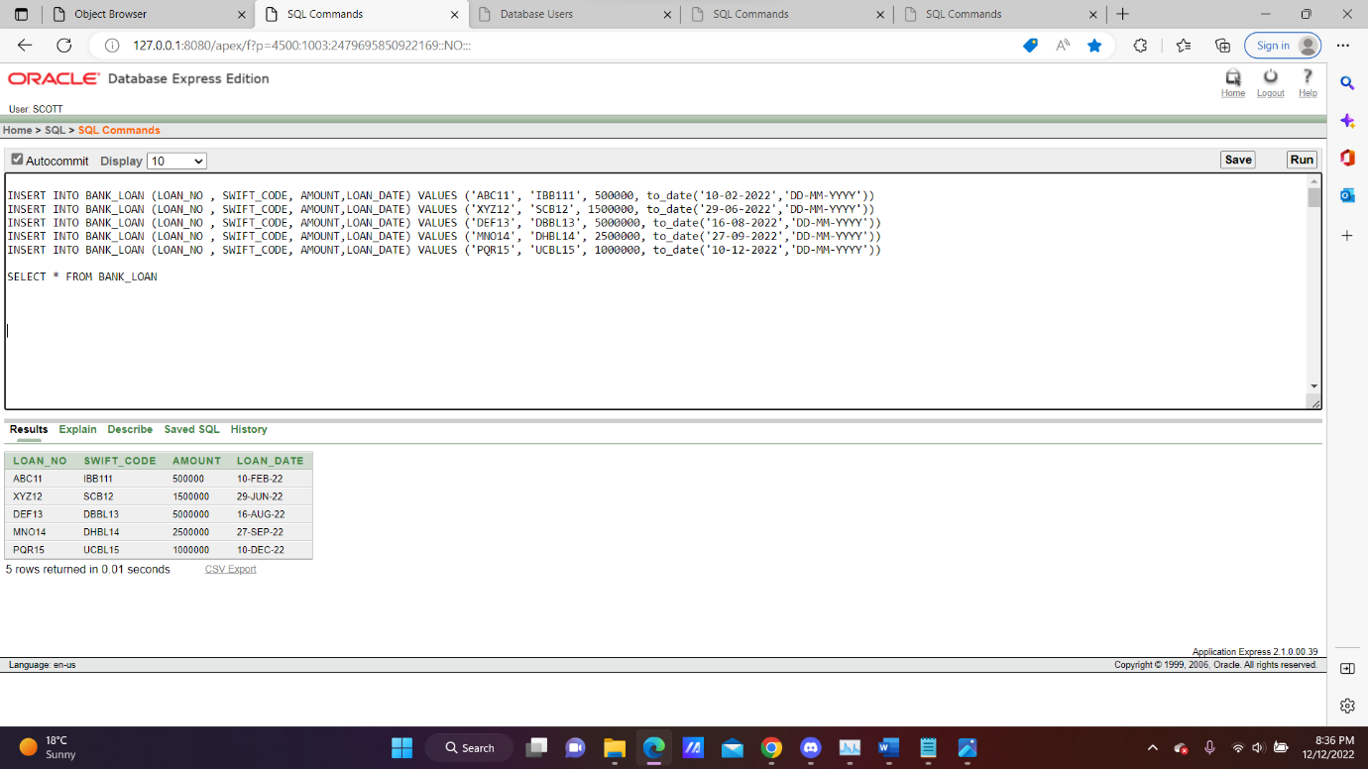

**JOINING**

**Equijoin-1:**

**Q.** Display all the bank information located in BARISHAL

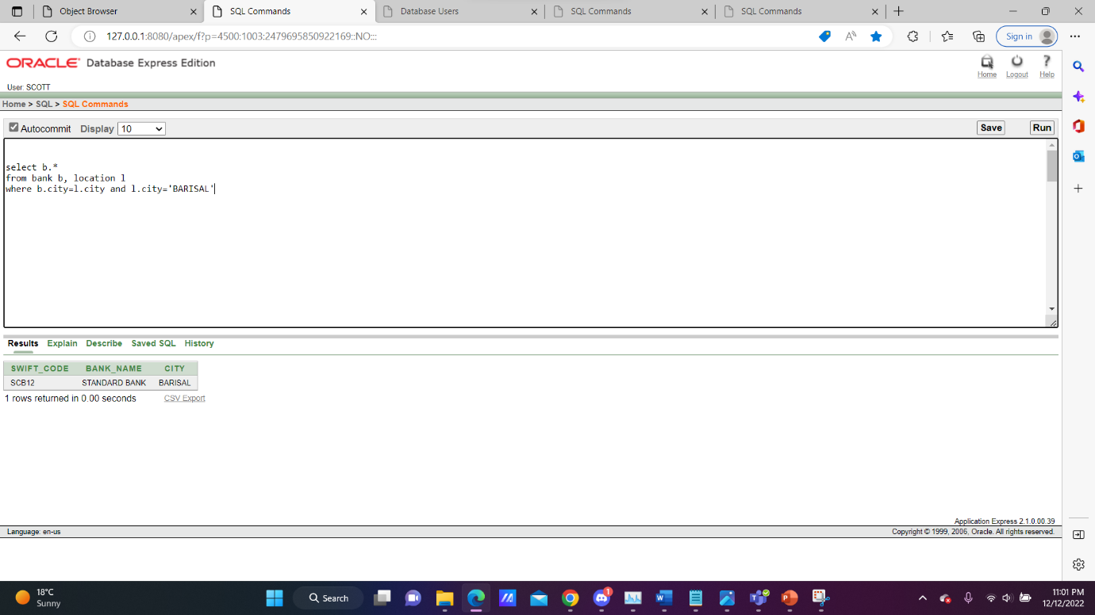

**Equijoin-2:**

**Q.** Display all the manager information who works in ‘ISLAMI BANK’

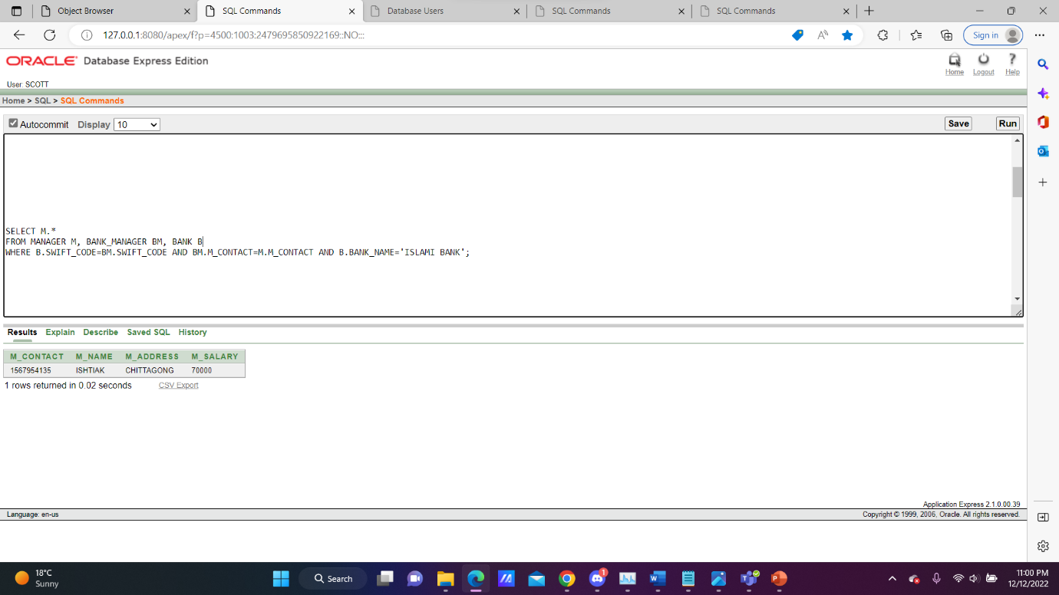

**Outerjoin-1:**

**Q.** Get the non-matching records from manager table

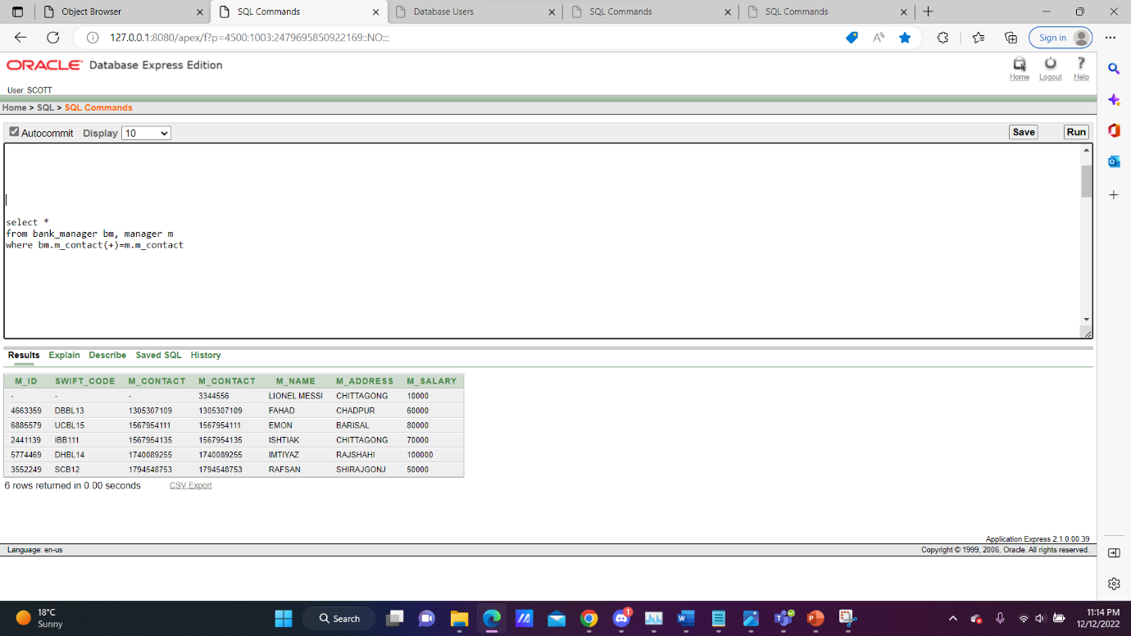

**Outerjoin-2:**

**Q.** Display all the employee’s information who have manager as well as who don’t have any manager

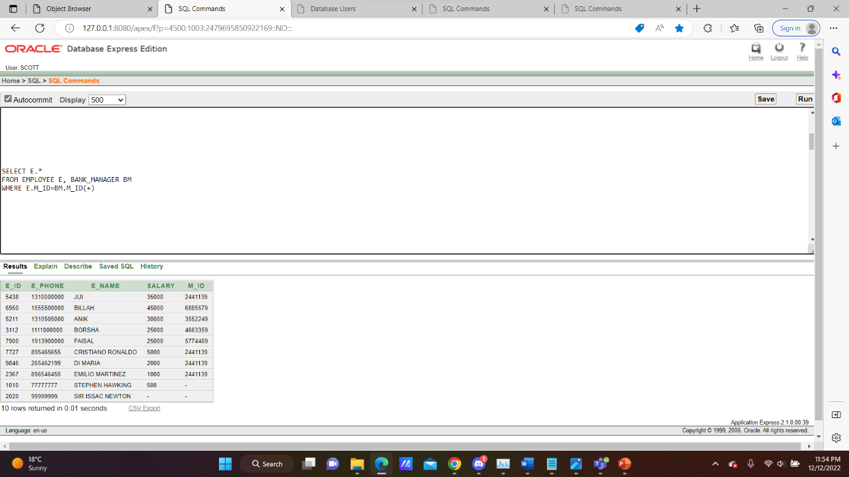

**Non-equijoin:**

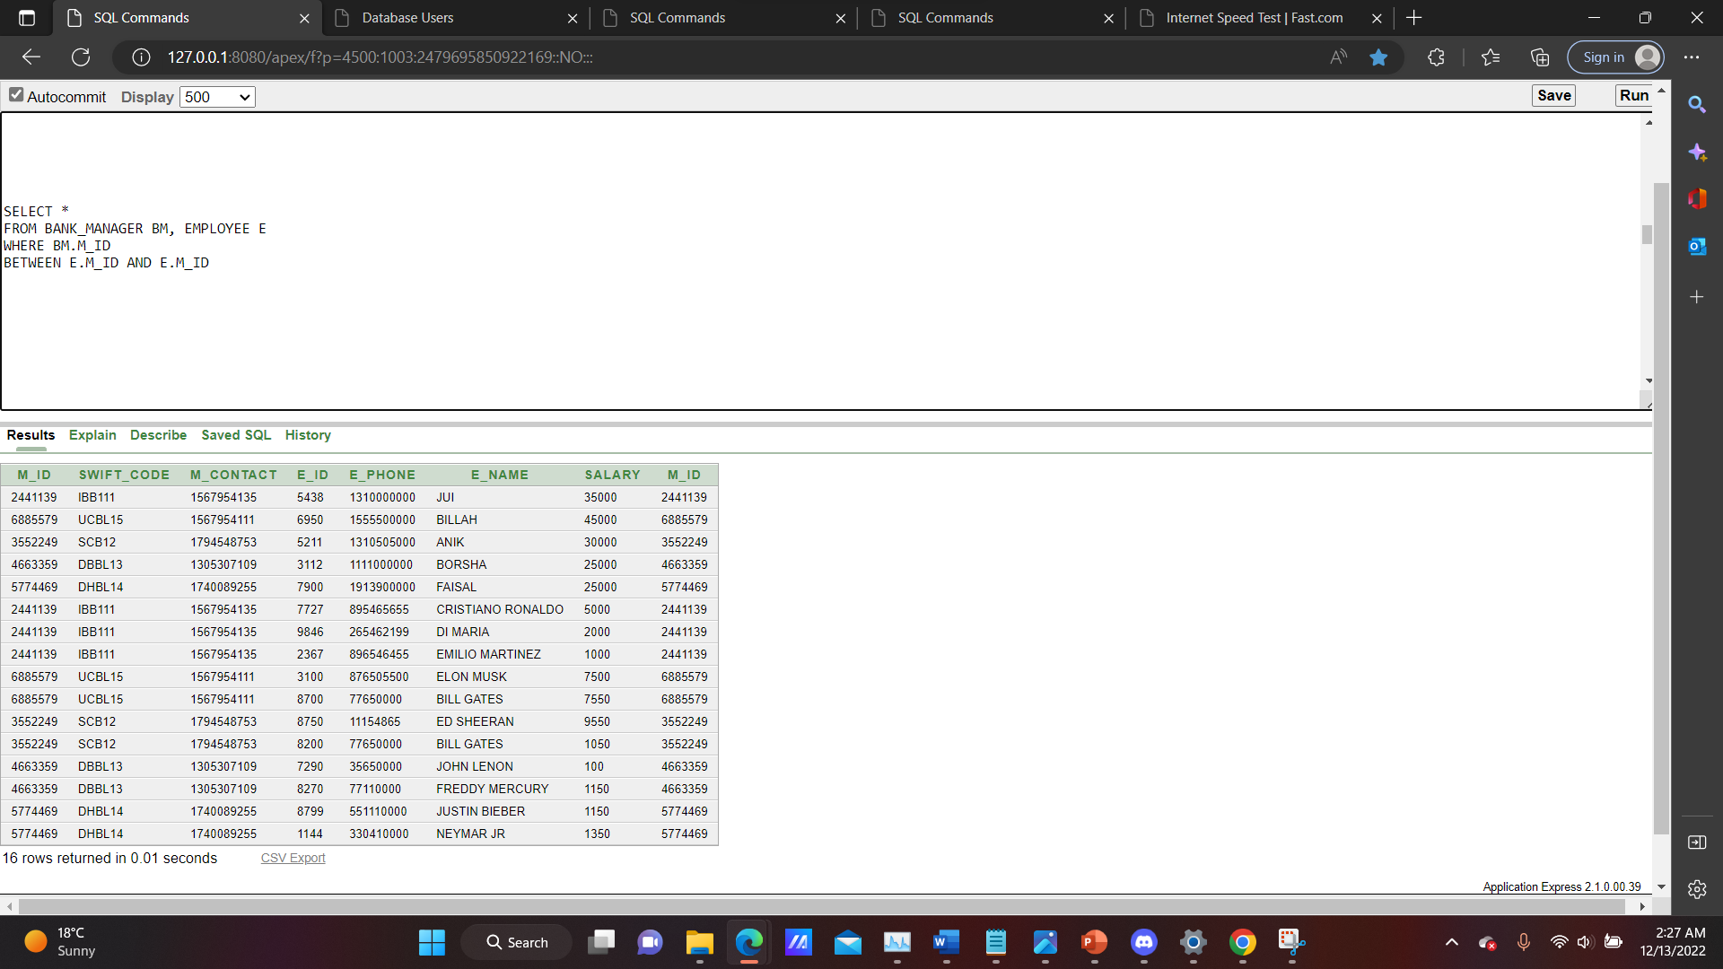

**Self-join:**

**Q.** Display the matching values of online shopping and the transport fee from payment table.

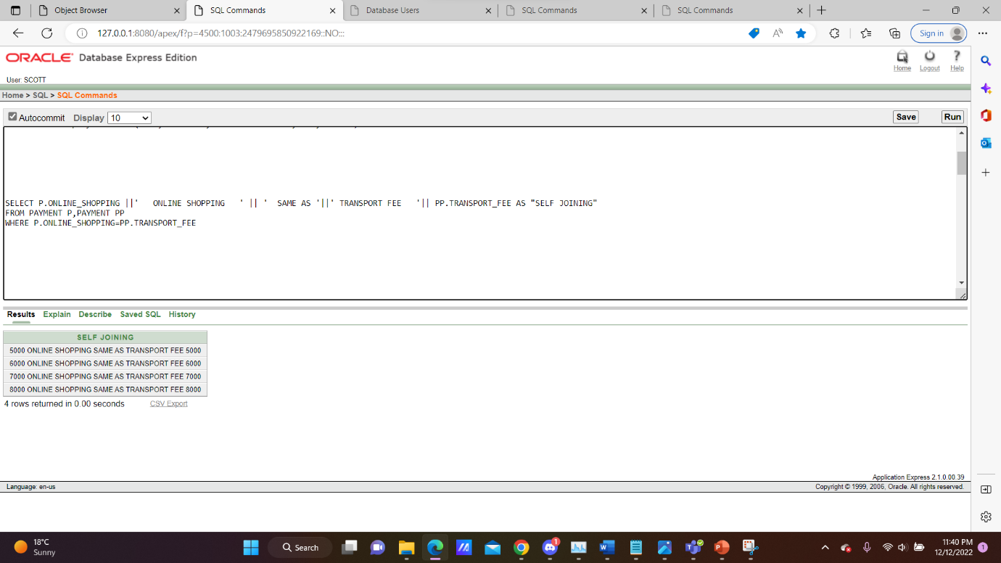

**SUB QUERY**

**Q1.** Display third maximum salary of manager

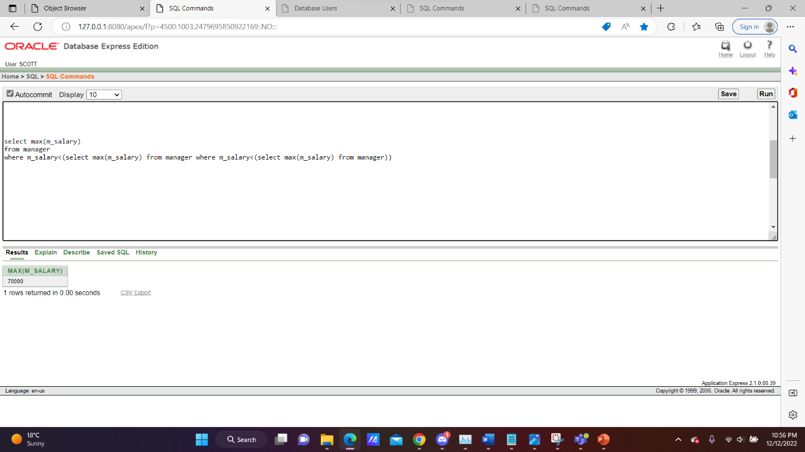

**Q2.** Display employee information whose address is in ‘BARISAL’

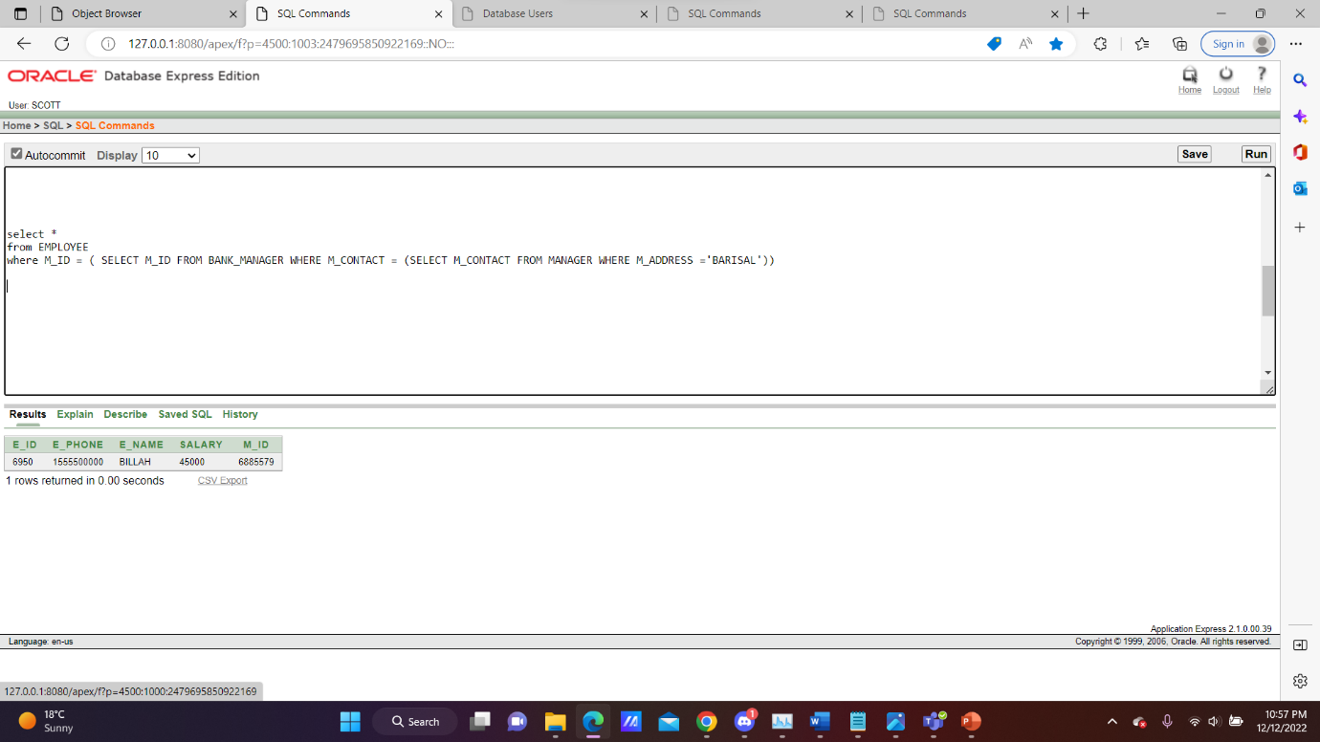

**Q3.** select all employee who are earning more than all mangers

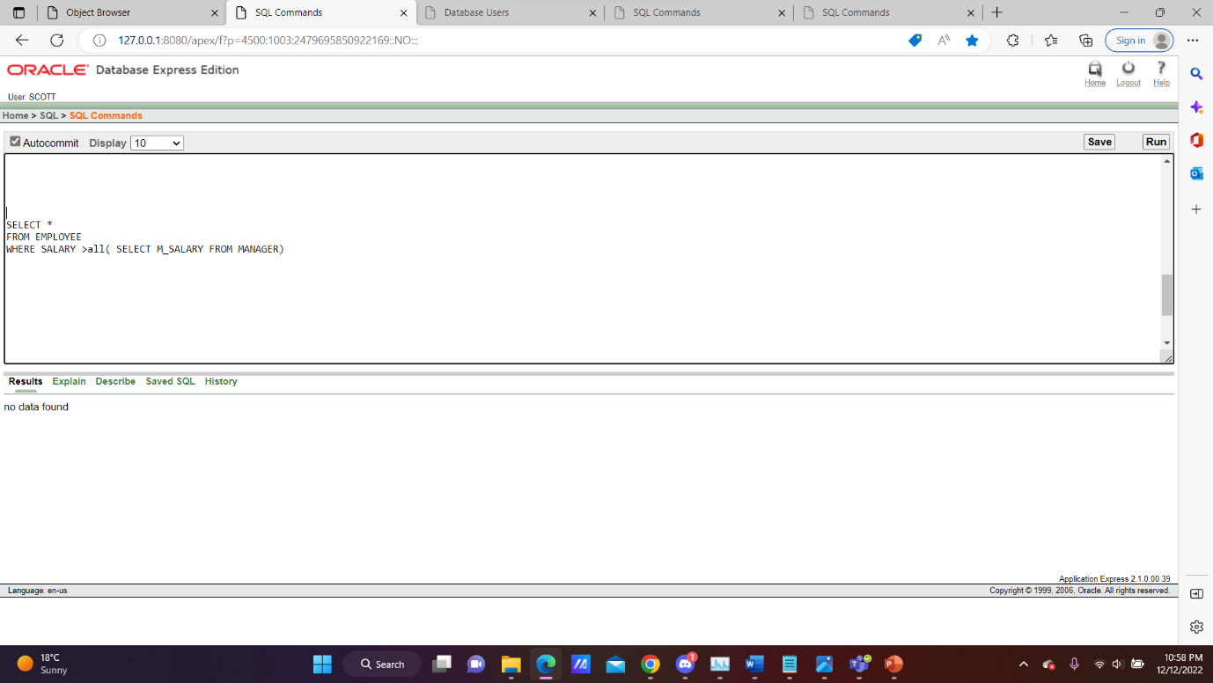

**Q4.** Display all client details whose education fees are between 30000 to 50000

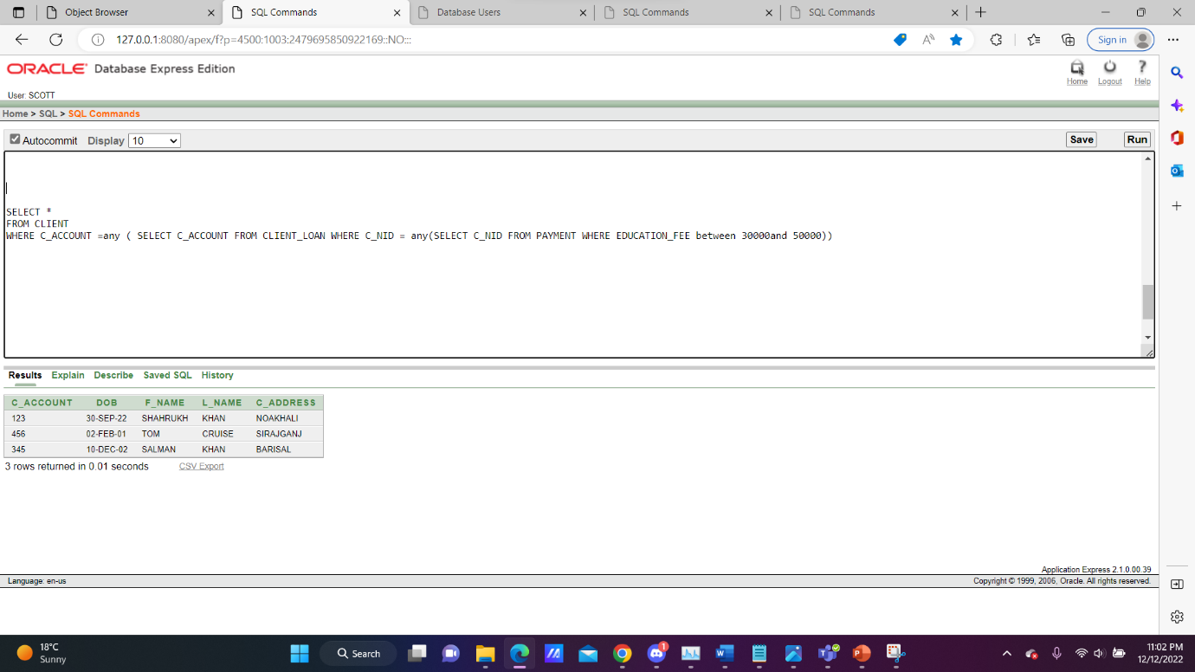

**VIEWS**

**Simple view:**

**Q.** Create a simple view named project_view based on project name and date.

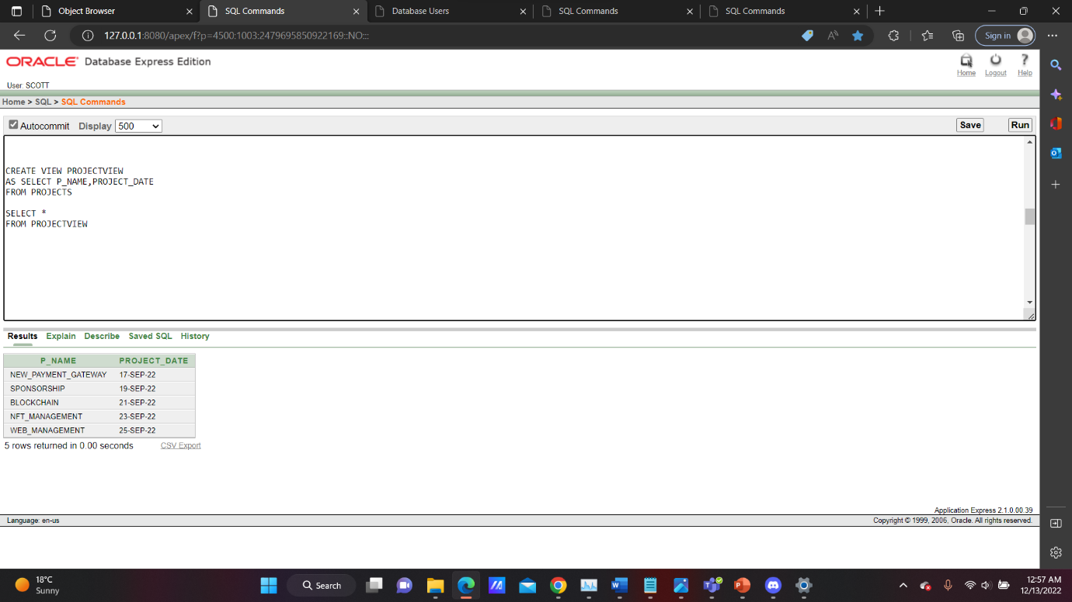

**Complex view:**

**Q.**

**CONSTRAINT**

**Q.** Add Education_Fee not null in payment table.

